# Main website

Similar page buttons (blue outline, white fill)

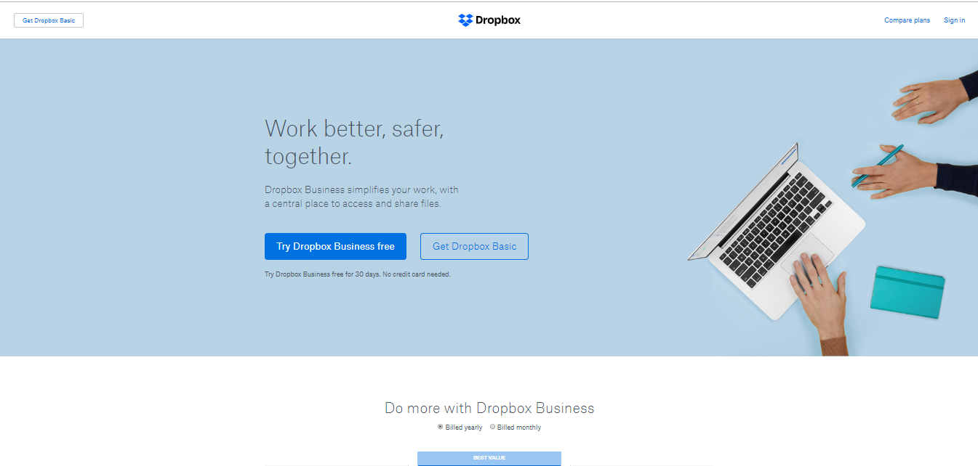

Logo on top of page

Similar font for headings

Secondary page:

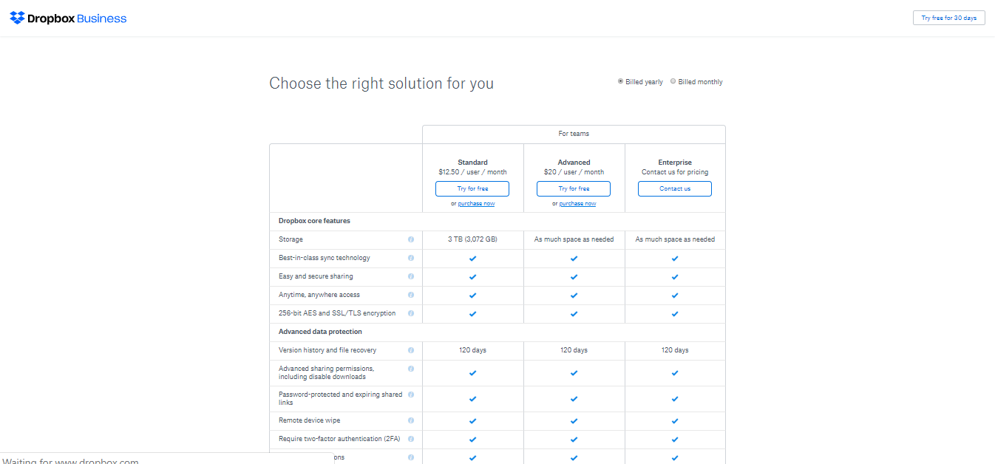

1. **Website: Dropbox.com**
   1. The first website’s layout has a big focus on simplicity and user-friendly interface. This can be seen from its huge emphasis on images and benefit to catch the user’s interest. The content layout looks to be designed to allow paper-based reading pattern, and is designed to be skimmed through, only highlighting the main points in the form of short sentences. This is highly suitable for consumers who are not familiar with tech jargons and only want to get things done. The second page, however, places more emphasis on functionality, clearly designed for business purpose. More jargons and dense information are used to compare the plans offered to businessmen. The content layout is designed for reading, and uses an F-based viewing pattern, highlighting the differences among to plans to entice businessmen to subscribe the more expensive plans. This is very suitable for businessmen to obtain a plan suitable for their business in Dropbox through clearly broken-down comparisons.
   2. Figure above Q1a
   3. .
      1. 

Active WS

Active WS

Passive WS

Active WS

Active WS

* + 1. 

Passive WS

Passive WS

Passive WS

Passive WS

Passive WS

Active WS

* 1. The design of the website is appropriate for its users. The homepage is clearly suitable for end-users, and the “choose plans” page is clearly suitable for businessman who can understand tech jargons.

1. **Website: http://arngren.net/**
   1. .
      1. 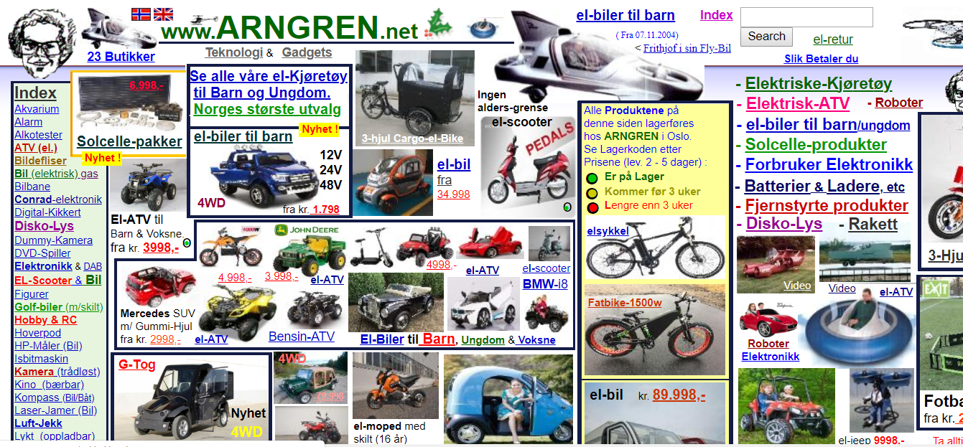

No clear color choices, many colors were used seemingly without reason

No proper organization of the website, content seemingly placed everywhere

* + 1. 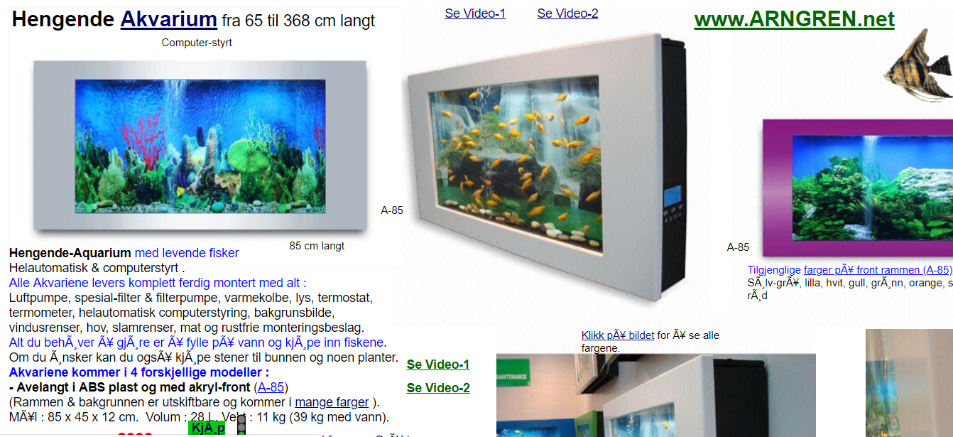
  1. Above (screen callouts)
  2. .
     1. Use a grid layout.
        1. Use a grid layout to properly organize content, placing images in a table, and properly placing text.
     2. Use a proper theme
        1. Decide on a proper website main theme and use consistent colors. Remove unnecessary bolding and headings.
     3. Use active white spaces
        1. Add white spaces to organize and separate text and graphics elements to avoid unnecessary need to “hunt” content on the site.

1. **Website: google.com, dropbox.com**
   1. The website that I tested are dropbox.com and google.com. The two websites are tested through Firefox 24.0, Opera 58.0.3135.47, and Chrome 69.0.3497.100. The most glaring difference across the browsers are the text used. The font family used is quite different from each other, although both still uses the same level of heading. This is likely due to the browser’s default font as the websites do not enforce a font family. Aside from that, the layout of the websites does not have a noticeable change. Lastly, the most glaring change is the graphics inconsistencies. Some of the color rendered are slightly different in terms of saturation. Besides that, especially on Firefox 24.0, the picture behind the buttons on the main page of dropbox.com is completely missing.